Heather Rice

Heather Rice is a dynamic Jazz artist and Singer Songwriter. Her passionate vocals have been compared to Celine Dion, Jane Monheit, and Patty Griffin. Recent releases include Rice's self titled album and "Fingers" a Jazz-fusion compilation with the Franklin Music Group. She has recently opened for Joan Osborn, Lee DeWyze, and Sheryl Crow and is a regular at the esteemed Bosendorfer Lounge.

The variegated styles, Rice's passionate and versatile vocals, and her claim on songs with solid melodic lines all add color and beauty to her music. Heather puts a unique, retro twist to modern music, giving you the feel of a sophisticated club while singing a mix of classic and current hits.
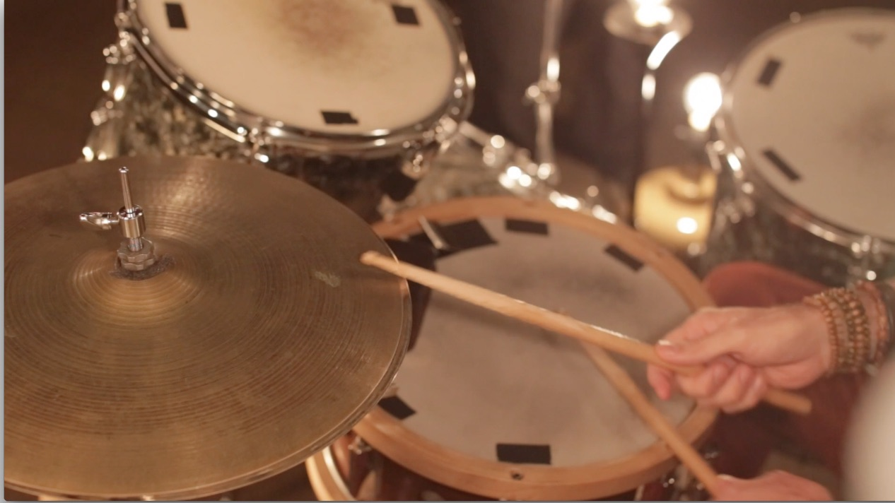
Heather Rice is accompanied by some of the finest musicians in the Southeast: Ben O'Riordan, Rion Smith, Marc Osborn, Tim Franklin, Ed Metz, Jeff Phillips, Tony Durrum, and Brendan May, Sunshine Matthews, and Tom Cooper.

Book her as a solo, duo, trio, all the way up to 7-piece band!

